**Download the R programming language**

<https://mirror.las.iastate.edu/CRAN/index.html>

**Download RStudio to run the R programming language**

https://rstudio.com/products/rstudio/download/

You also need to install PDFTK onto your computer

<https://www.pdflabs.com/tools/pdftk-server/>

Brother Hathaway can help know how to do this

Create “New Project” and name it something

Inside that new project folder that is on your computer, create a “Data” folder and paste in the *TrialBalanceTemplate*, *TaxPacket*, and *BreakdownScript* files

The first time you open RStudio, paste the following into the Console at the bottom:

install.packages("mosaic")

install.packages("tidyverse")

install.packages("readxl")

install.packages("here")

install.packages("purr")

install.packages("dplyr")

install.packages("stringr")

install.packages("writexl")

install.packages("DescTools")

install.packages("openxlsx")

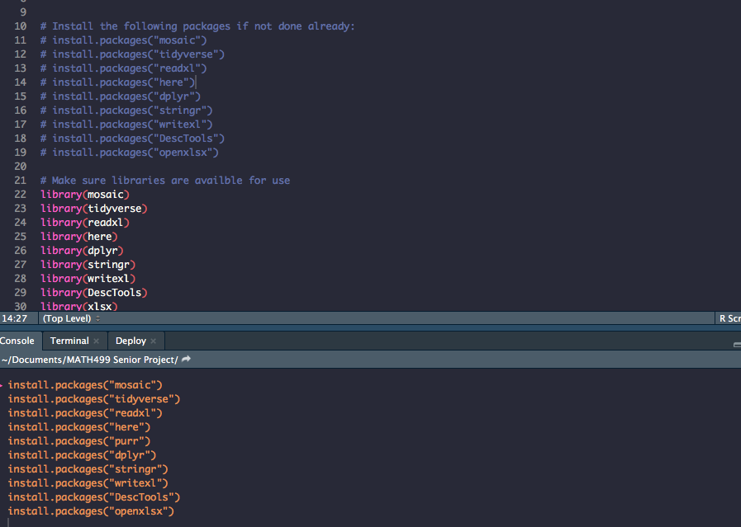

Then open the *BreakdownScript*  file, make sure the template you want to run has been input

*

The folder your project is in, should contain files called “UpdatedTest.xlsx” and “UpdatedTaxPacket.pdf” with the documents you need.